Identifying Character Traits

Character actions show us what kind of people these characters are: friendly, sad, nosy, confused, inventive, brave, etc.

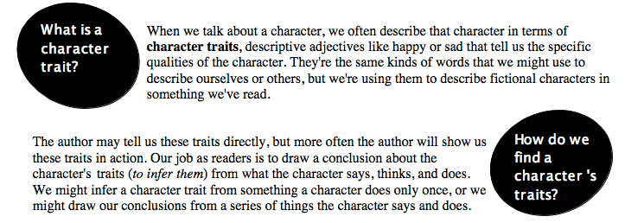

Actions | Character Trait revealed

